|  |  |
| --- | --- |
| Date | 16 october 2022 |
| Team Id | PNT2022TMID43466 |
| Project Name | Emerging Methods For Early Detection Of Forest Fires |
| Maximum Mark | 4 Marks |

User

Feedframe Camera

Frames from Video

Deep learning

alarm

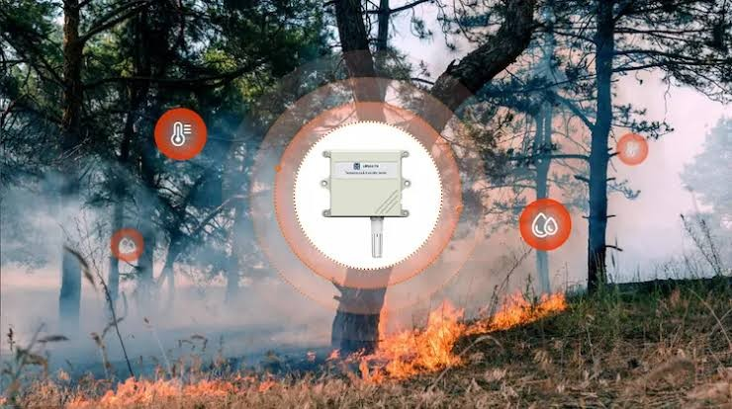

Forest

u